# GAMES SEARCH/ RESULTS: USER REQUIREMENTS

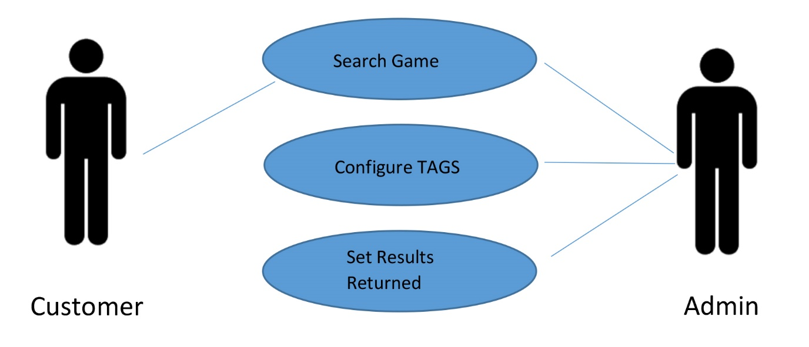

## GAME SEARCH/ RESULTS

Any user or customer will have the opportunity to search a game on the “Game On” website. The user or customer will have the option of searching for the game based on the name of the game or the genre of the game. User/ customer will type in words or partial words and the search database will show the listing of the games that are matching to the letters the customer has put in the search bar.

The “Game Search” use case contains the following basic steps:

1. Customer will search for a game based on the name or genre
2. GameOn will search it’s database and return the results
3. User may search with words or partial words.

## SEARCH GAMES

Any user should be able to search any game based on the name of the game or based on the genre of the game. The user will be able to type in words or partial words of the game or the genre of the game and the system should display results based on the input the user has typed. If the user types in a game or a genre of a game that is not in the database, the system will return “not found”.

The “search game” use case contains the following basic steps:

1. Game On user will enter name or genre of game in the search bar
2. Game On system will search the database
3. If game or genre is found in the database the system will display the information
4. If fame or genre is not found in the database the system will display “not found”.

## CONFIGURE TAGS

The admin will configure tags in two ways. One will be based on the name of the game, and the other will be based on the genre of the game. If the user enters the name of the genre it will only search games within that genre. If the user enters partial words that are a name of a game it will display names of the games only. The admin will configure tags and save them in the “Game On” database.

The “configure tags” use case contains the following basic steps:

1. Admin will create tags for the games or game genres
2. Admin will submit tags
3. If the admin correctly submits tags the system will create the tag and save it inside the database of the website
4. If the admin fails to correctly submit tags, then the system will notify the admin and the admin will have to make correction and begin from the top

## SET RESULTS RETURNED

The customer will search for a game or a genre of a game in the search bar and the number of matching results will be displayed. The customer will be typing words or partial words to the name of the game or the genre of the game. Based on the matching letters the amount of results should be displayed. If the user types a name of the game or a genre of the game and the system doesn’t recognize it, the system will return, “0 results found”.

The “set results returned” use case contains the following basic steps:

1. The user will enter the name or genre of a game
2. The system will search for it in the database
3. If the game or genre of game is found in the database, the system will return the amount of results found
4. If the game or genre of game is not found in the database, the system will return, “0 results found”.

# SYSTEM REQUIREMENTS

## SEARCH GAMES/RESULTS

The following table outlines the details of use case # 1: Search Games

|  |  |
| --- | --- |
| Use Case ID:1 | Search Games |
| Description | Customers will search for a game by, the game name or the game genre and the search should understand that the customer may type partial words, it may not be an exact match.  The search will then display the game information that are in match with the customer search. |
| Input | * Name of Game * Genre of Game |
| Output | If transaction was successful, then the system will display the information of games. If the transaction failed, the system will return the message “No match”. |
| Preconditions | The database of games should be connected to the search bar in order to correctly display the information the customer would be asking for. |
| Post Conditions | If succeeded, the results of the games searched will be displayed. |
| Frequency of Use | Many time a day |

## CONFIGURE TABS

The following table outlines the details of use case # 2: Configure Tabs

|  |  |
| --- | --- |
| Use Case ID: 2 | Configure “TAGS” |
| Description | The administrator will configure tags in two parts. The first will have tags for genres and inside genres will be names of games.  When the customer searches based on the genre it will search that particular genre only, but if the customer searches by the game name then it will search the entire database of games. |
| Input | * Games based on Genre * Name of Games |
| Output | If the search matches the tags, the results will be displayed. If the search does not match or fails, the admin will display, “not found”. |
| Preconditions | The Email/Username does not exists within the system at the time the user submits the form. |
| Post Conditions | The admin will configure tags before any customer is able to search for games. |
| Frequency of Use | Once, when making the database of genres and games. |

## SET NUMBER OF RESULTS RETURNED

The following table outlines the “set number of results returned” use case details:

|  |  |
| --- | --- |
| Use Case ID: 3 | Set the number of Results Returned |
| Description | The customer will search for a game or genre of a game in the search bar and the number of matching results will appear on the screen.  The customer will be typing in partial words or words that are related to their search. |
| Input | * Genre of Game * Name of Game |
| Output | If the search was successful and there was a match to the genre or games the number of matches or results will be returned.  If the search failed or did not have a match to the database, the admin will display, “0 results found”. |
| Preconditions | The admin should be able to recognize words or partial words of the game or genre. |
| Post Conditions | If there is a match, the system will display the number of results found.  If the match is not found, the system will display, “0 results found”. |
| Frequency of Use | * Many times in day |

# SYSTEM MODELS

## SEARCH GAMES

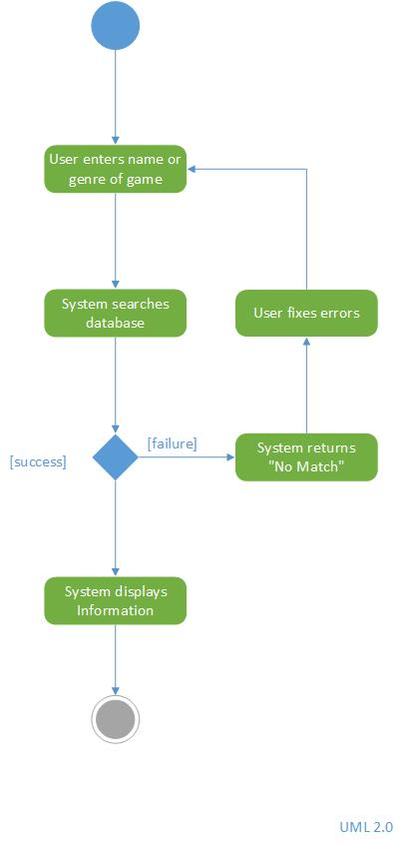

This diagram describes the process that takes place in the search games process. The user or customer will enter the name of the game or the genre of the game they would like to search. The user/ customer can enter words or partial words in the search bar.

Once the user/customer presses enter, the system will search the database. If the search was successful, the system will display the information of the game.

If the search failed, the system will return a message saying “No Match”. The user/ customer will have to fix the errors and retype their search in the search bar.

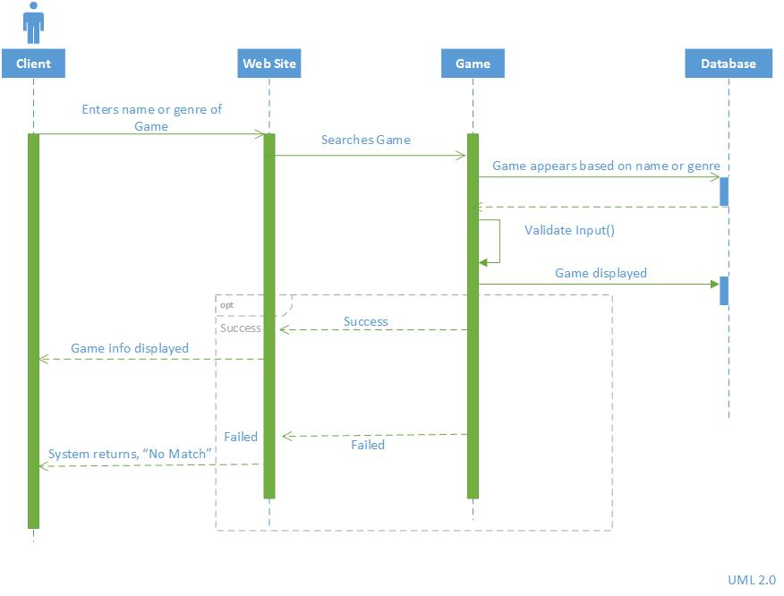

## CONFIGURE TAGS

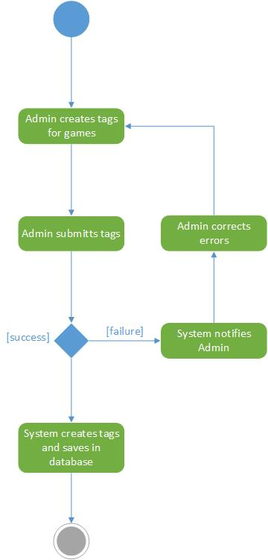This diagram describes the process that takes place as part of the configure tabs process. An admin will create tags for the games they would like to create for. The admin will create tags based on the name of the game or the genre of the game. Then the admin will submit the tags.

If the tags are made successfully, the system creates tags and saves it in the database. If the tags are not made successfully, the system will notify the admin. The admin will correct the errors and the admin will recreate the tags for submission.

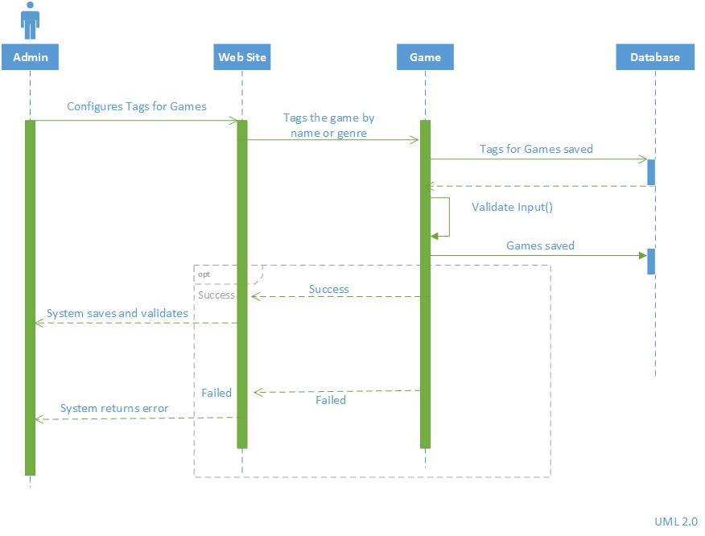

## SET RESULTS RETURNED

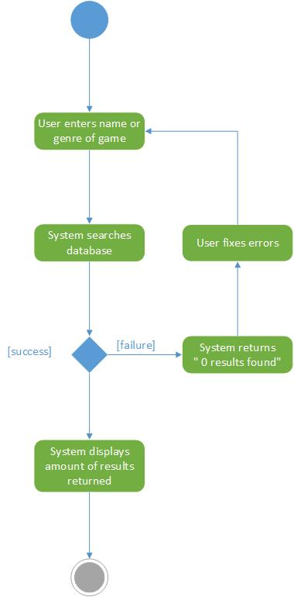

The diagram describes the process that takes place as parts of the set results retuned process. The user/customer will enter the name or genre of the game they like to view. The system will search the database of games.

If the search was successful, the system will display the number of results that are returned. If the system fails, it will return a message saying, “0 results found. Thereafter, the user/customer will have to fix the errors and re-enter into the search bar again.

